Lesson 6 Demo 1: Set up Apache Web Server Using Ansible

This section will guide you to:

* Set up an apache web server using Ansible.

This lab has four sub-sections:

* Install Ansible on Ubuntu
* Establish connectivity between ansible controller and node machine
* Write Ansible YAML script to install ansible software
* Run Ansible YAML script

**Step 1:** Install Ansible on Ubuntu

* Use the below commands on Ubuntu system to install ansible software:

**sudo apt-get install software-properties-common**

**sudo apt-add-repository ppa:ansible/ansible**

**sudo apt-get update**

**sudo apt-get install ansible**

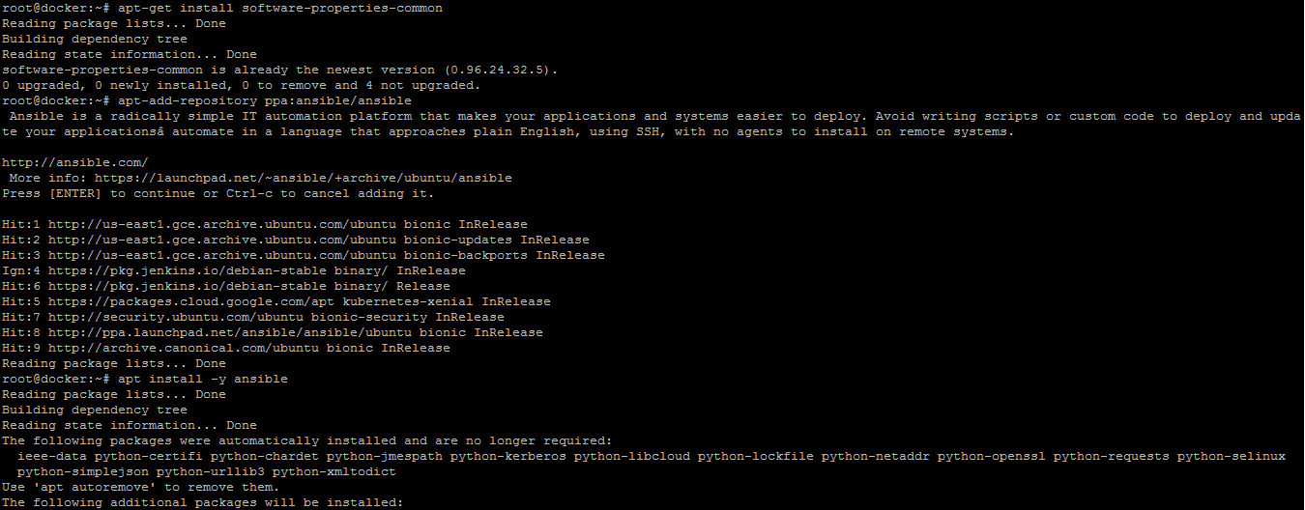

* Establish SSH key pair in linux system to have SSH connectivity with localhost using the following commands:

**ssh-keygen -t rsa**

**cat /root/.ssh/id_rsa.pub**

**copy the ssh key from here**

**nano /root/.ssh/authorized_keys**

**paste the key here and save the file**

**ssh localhost -p 42006**

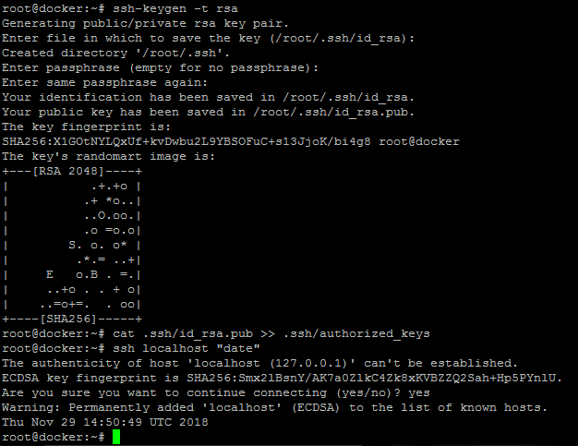

* Now, add the host localhost in ansible host file /etc/ansible/hosts.

**sudo vi /etc/ansible/hosts**

* When the file opens, add the following content:

**[webservers]**

**localhost:42006**

**Step 2:** Establish connectivity between Ansible controller and node machine.

* Execute the below command to validate the host inventory file:

**ansible -m ping web servers**



**Step 3:** Write Ansible YAML script to install Ansible software

* Once connectivity is established, add the following code in the apache.yaml file and proceed with execution:

**sudo vi apache2.yaml**

* Add the code given below in **apache2.yaml:**

**---**

**- hosts: webservers**

**become: true**

**tasks:**

**- name: install apache2**

**apt: name=apache2 update_cache=yes state=latest**

**- name: enabled mod_rewrite**

**apache2_module: name=rewrite state=present**

**notify:**

**- restart apache2**

**handlers:**

**- name: restart apache2**

**service: name=apache2 state=restarted**

**Step 4:** Run Ansible YAML script

* Run apache.yaml file using below command:

**ansible-playbook apache2.yaml**

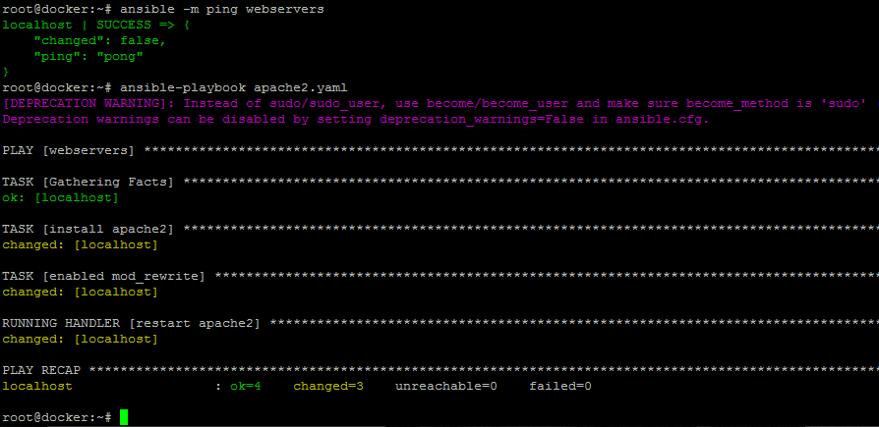

* Validate installation using the command:

**ansible -m shell -a "service apache2 status" webservers**

